LAB DAY 12:

Name: GOPIKA J Reg NO:192324032

1.Kruskal’s Algorithm:

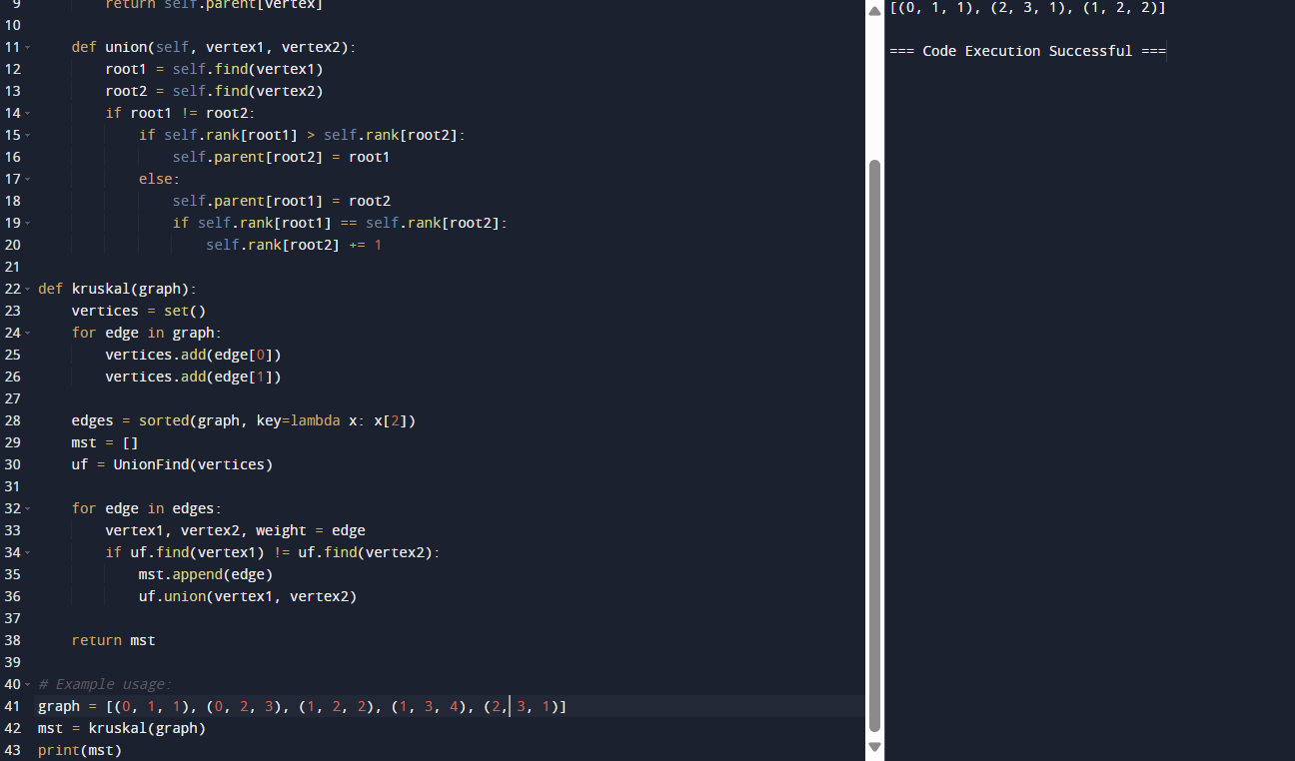

2.Dijkstra Algorithm:

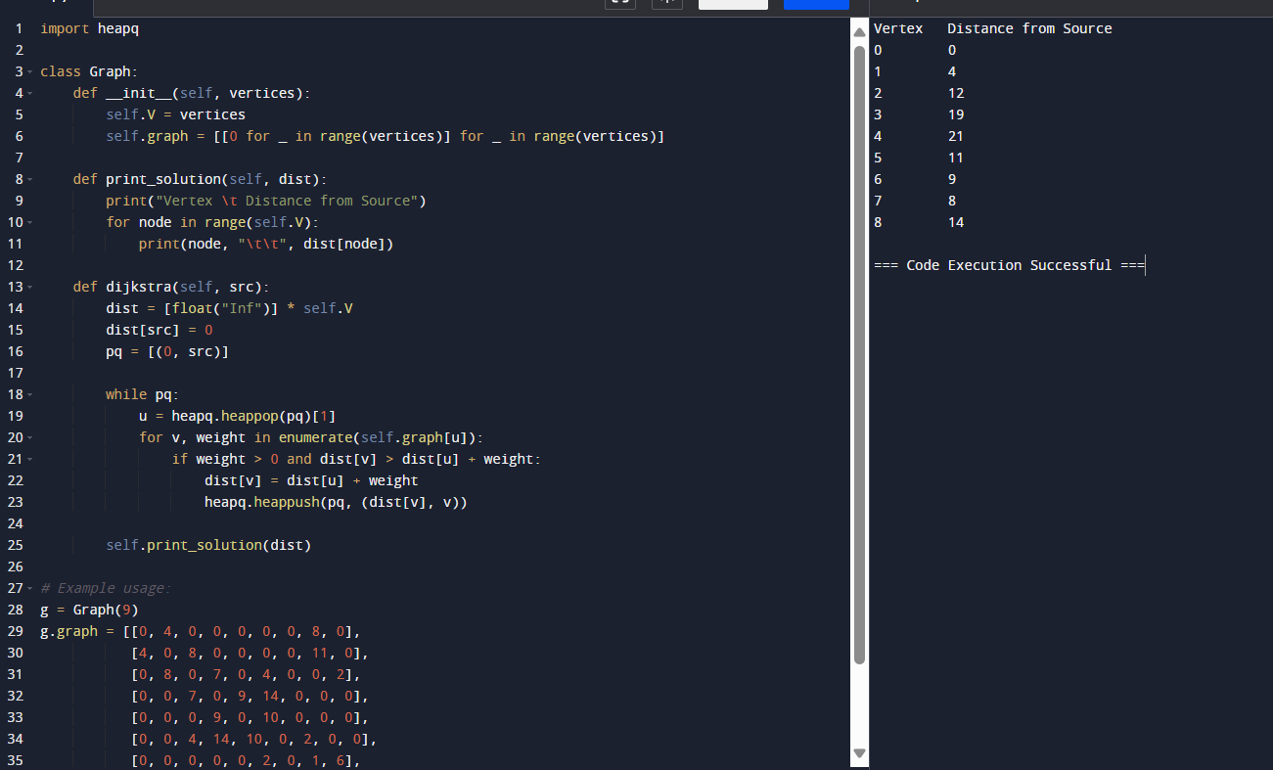

3.Container Loading:

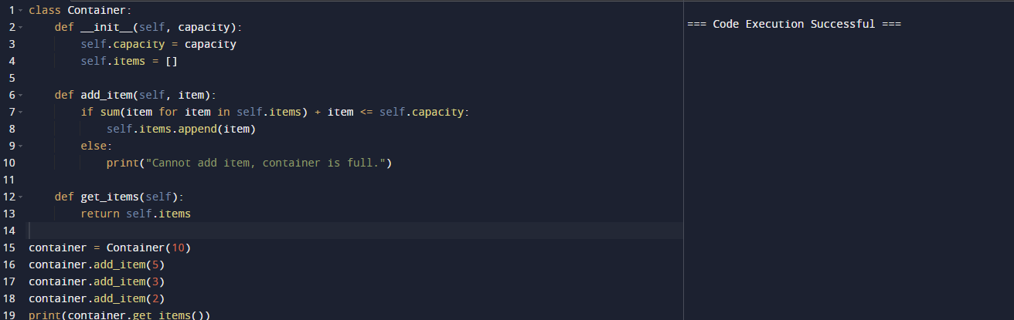

4.Boruvka Algorithm:

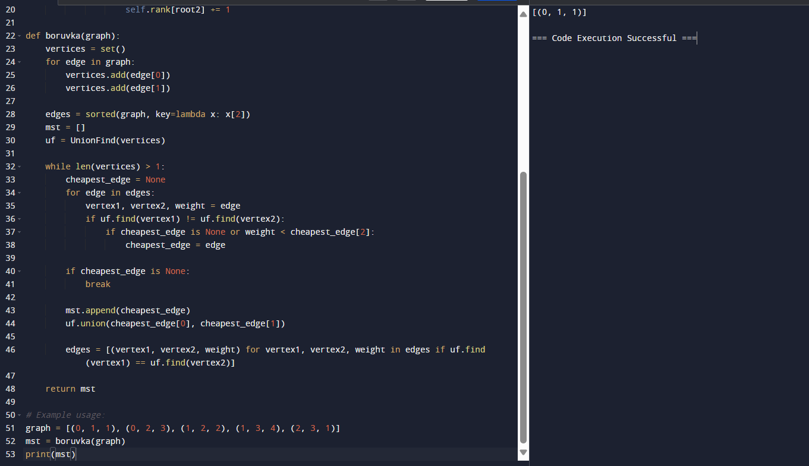

5.Huffman Algorithm:

